Chapter 9, Problem 34.

What value of ω will cause the forced response, v_{o}, in Fig. 9.41 to be zero?

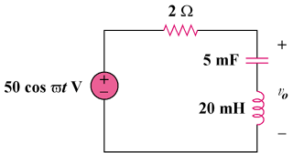

Figure 9.41
For Prob. 9.34.

